Please order _____Fence(s)

Name: _________________________________________________________

Phone: (________) ______________________________________________

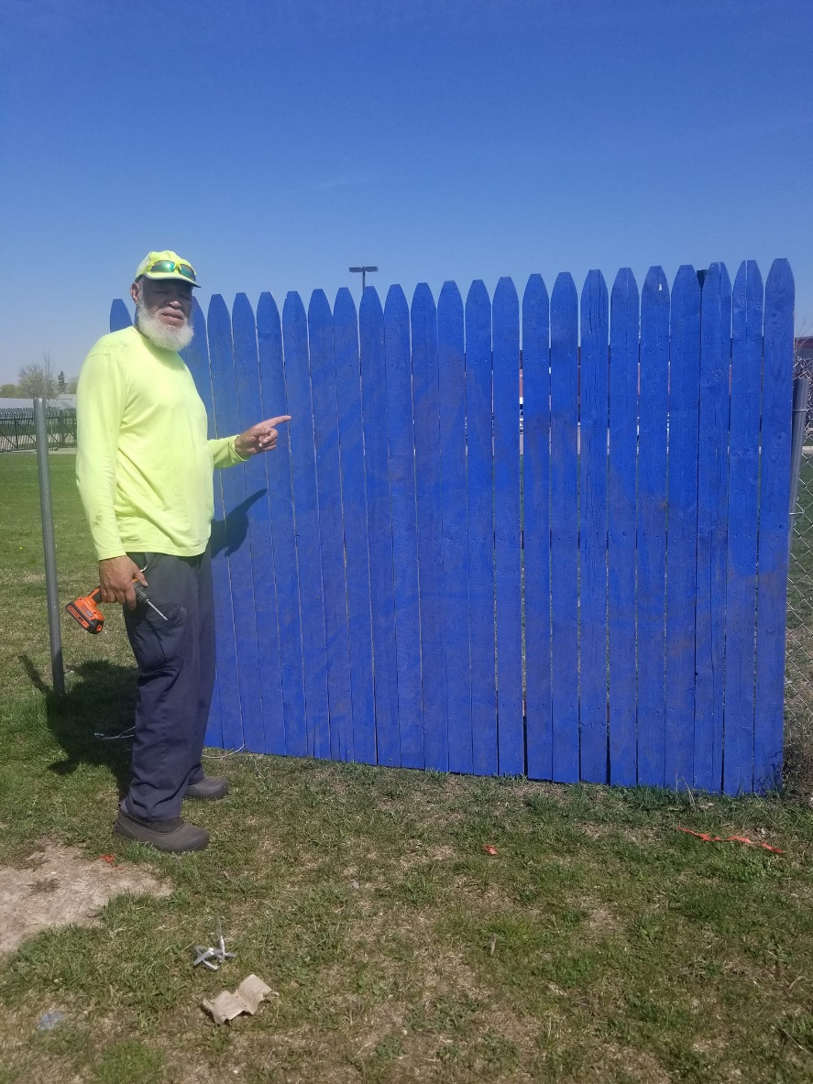



The 6x8 fence purchase is $150.00 which includes:

1. Fence
2. Hardware

You may purchase a fence for your graduating class or memorial fence for a loved one.

You may select the artist of your choice to handle the artwork. Blue and gray background only.